package main

import (

"database/sql"

"fmt"

"log"

_"github.com/mattn/go-sqlite3"

)

func main() {

db, err := sql.Open("sqlite3", "studentdb")

fmt.Println("Opened Student Database Successfully")

if err != nil {

log.Fatal(err)

}

defer db.Close()

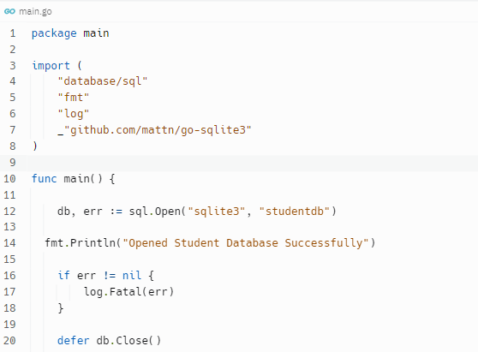

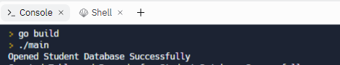

sts := `

DROP TABLE IF EXISTS Registration;

CREATE TABLE Registration(id INTEGER PRIMARY KEY, Name TEXT, Age INT, Address TEXT, Program TEXT, Phone INT(4));

INSERT INTO Registration(Id, Name, Age, Address, Program, Phone) VALUES(1,'Bikram',32, 'Siliguri', 'DevOps', 0000);

INSERT INTO Registration(Id, Name, Age, Address, Program, Phone) VALUES(2,'Pritha',29, 'Kolkata', 'MBA', 0000);

INSERT INTO Registration(Id, Name, Age, Address, Program, Phone) VALUES(3,'Durga',29, 'Hyderabad', 'Software Development', 0000);

INSERT INTO Registration(Id, Name, Age, Address, Program, Phone) VALUES(4,'Romesh',32, 'Manipur', 'ITIL', 0000);

`

_, err = db.Exec(sts)

if err != nil {

log.Fatal(err)

}

fmt.Println("Created Table and Records for Student Database Successfully")

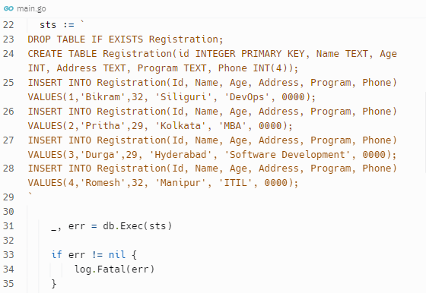

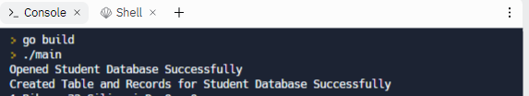

rows, err := db.Query("SELECT * FROM Registration")

if err != nil {

log.Fatal(err)

}

defer rows.Close()

for rows.Next() {

var Id int

var Name string

var Age int

var Address string

var Program string

var Phone int

err = rows.Scan(&Id, &Name, &Age, &Address, &Program, &Phone)

if err != nil {

log.Fatal(err)

}

fmt.Println(Id, Name, Age, Address, Program, Phone)

fmt.Println("Operation for Student Database Executed Successfully")

}

}

Reference link

<https://replit.com/@bikram04/CompassionateBoldCharactermapping#main.go>

